**Developing a multiscale and transdisciplinary agrobiodiversity management framework for the Hindu Kush Himalayan region**

**1. Introduction**

Agrobiodiversity represents a vital subset of biodiversity that relates to biodiversity in food and agricultural systems. It is the “variety and variability of animals, plants and micro-organisms that are used directly or indirectly for food and agriculture, including crops, livestock, forestry and fisheries. It comprises the diversity of genetic resources (varieties, breeds) and species used for food, fodder, fibre, fuel and pharmaceuticals. It also includes the diversity of non-harvested species that support production (soil micro-organisms, predators, pests, pollinators), and those in the wider environment that support agro-ecosystems (agricultural, pastoral, forest and aquatic) as well as the diversity of the agro-ecosystems, including associated cultural knowledge and practices” (FAO, 1999).

Agro-biodiversity is an evolutionary divergent, highly interrelated component of biodiversity dealing with agroecosystem and variation in agriculture related to plants, animals, marine life, insects, microbes, avian species, etc. All environmental, biological, sociocultural, economic, political, and health factors are responsible for the evolution of diverse agroecosystems. Importantly, agrobiodiversity requires human interference to diversify and evolve. Therefore, knowledge, practices, culture, and tradition of farming community working directly on agroecosystems are integral.

In the HKH, agroecosystems represent diverse production systems from traditional agroecosystems to commercial, and comprise diverse practices and knowledge of crop husbandry, animal husbandry, fisheries, and forests and other natural ecosystem interlinked functions and services. Knowledge systems associated with agrobiodiversity is thus diverse and interdisciplinary. They entail knowledge in agriculture (crop selection, intercropping, farming works), animal husbandry (breeding, livestock characteristics and requirements, fodder, ethnic veterinary medicines), management of natural resources (water, soil, pest management, forest maintenance), health and nutrition (food, cuisines, medicines), community development (common, shared, specialized knowledge among community members, institutions) and livelihoods (business and marketing.

These knowledge systems is crucial to understand people’s relationships with nature (Bennett et al 2106), especially at the time of ‘anthopocene or the age of intense planet-people interactions (Zimmerer et al, 2019), and that agrodiversity needs to be understood from its wider value perspective.

For the Hindu Kush Himalayan region, where livelihoods of majority of populations are dependent on nature-human coupled resource systems such as agriculture, aquaculture, animal husbandry, the knowledge on agrobiodiversity, its management and conservation remain fragmented, and its prospects to bring transformative change is less explored or highlighted.

**Intention behind this systematic review is**: To provide direction to ICIMOD’s regional programmes (in particular, the Transboundary Landscape Regional Programme) to define action interventions that can be implemented in the HKH member countries (particularly in the four transboundary landscapes) that can help agrobiodiversity diversity, evolve and become resilient, sustain wider ecosystem services, enhance its prospect to address food, nutrition, and livelihood security, and bring transformative change for people in the HKH region.

**The direction for this systematic review is thus:**

* To develop an action intervention framework based on knowledge trend in the published literature around agrobiodiversity in the HKH.

Transdisciplinary and multiscale approach is adopted to conceptualize the framework- so as to make interventions suggested relevant to the transboundary landscape regional programme and to the stakeholders at different scale of interventions.

The overall approach of the systematic review is summarized in the figure below:

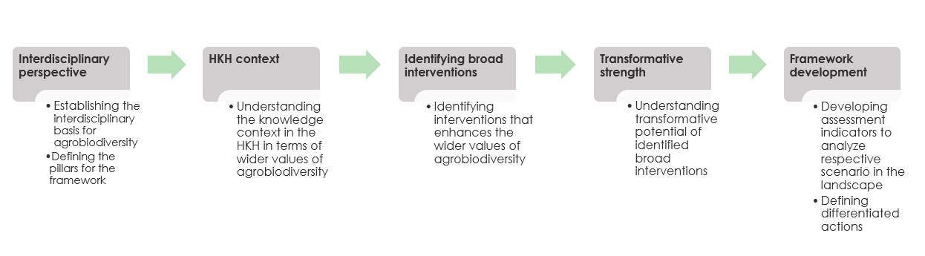

**2. Methodology**

The paper adopts meta-synthesis approach for literature review (Grant and Booth, 2009). The approach implies to the analysis and transformation of past information and knowledge into new conceptualization and interpretation. The method fits well with the objective of our paper to develop a multiscale and transdisciplinary action framework for agrobiodiversity management in the Hindu Kush Himalayan region, building upon the available science knowledge and ground practices.

Focus is on literature featuring the eight Hindu-Kush Himalayan region- incorporates landscape units of eight countries- Afghanistan, Bangladesh, Bhutan, China, India, Myanmar, Nepal, and Pakistan.

The review incorporates a combination of **Search, Appraisal, Synthesis, Analysis** (SALSA) and snowballing steps as outlined in Malinauskaite et al (2019), and includes 5 steps elaborated below:

**Search**

The step entails finding relevant publications around the concept of agrobiodiversity use and application. Academic literature was searched through ‘Scopus’ database using the topical search key words *agrobiodiversity* or *agrodiversity*. Given the large volume of literature time frame for last 25 years (1995-2000) was chosen. Scopus search retrieved a total of **936 publications.**

Agrobiodiversity #873

Agrodiversity #71

11 duplicates removed.

**Appraisal**

The step implies to narrowing down broader literature base to the most suitable ones using logical criteria. Screening criteria used is the geographic location units within the ICIMOD’s HKH boundary. This brought down the publication list to **115 publications.**

**Snowballing**

Snowballing technique (Creswell, 2007) was now applied to search additional references that would strengthen conceptual and thematic understanding of the concerned topic. A quick vosviewer analysis using 936 publications helped identify topics closely associated with agrobiodiversity conservation and management. Thus these keywords - *traditional agriculture*, *conservation agriculture*, *climate-smart agriculture*, *precision agriculture*, *mountain agriculture*, *subsistence agriculture*, *agriculture innovation, integrated pest management, integrated farming*, *family-farming, small-holder farming*, *women farmers, gender and agrobiodiversity, crop wild relatives, wild edibles, crop diversity, crop cultivar, livestock breeds, on-farm conservation, future smart crops, traditional crops, underutilized crops, ethnic foods, food and nutrition, agribusiness, agritourism, climate change and agrobiodiversity, in-situ conservation, ex-situ conservation, future smart crops, resilience, soil management, water management, seed network, and home garden* were used to search additional publication using ‘Scopus’. The limit of 25 years and HKH countries were retained. Additional literature from ICIMOD’s central document repository and online digital library – HimalDoc (<https://lib.icimod.org/>) was also added to the list to widen thematic resources for the HKH region. Special attention was paid to two keywords - ‘*mountains*’ and ‘*gender*’. A total of **3276** **publications** were then taken to the next synthesis step.

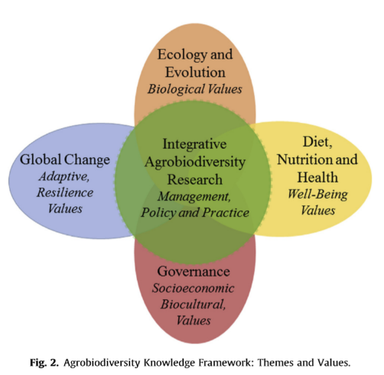**Synthesis**

This entailed a thorough process of geographic and thematic screening. Followed 2 steps:

Step 1. Geographic screening- publications from HKH countries that was from outside the ICIMOD’s HKH premises for example from Eastern China provinces, Southern Indian States were removed. For countries such as Bhutan, Myanmar, Afghanistan, because retrieval in Scopus was limited, all publications were included. This screening led to selection of final **838** publications which was then taken for thematic screening.

Thematic screening was done based on the integrated research framework by Zimmerer et al (2019) that reflected on the **wider values of agrobiodiversity** (see figure from the said publication). The sorting was done through reading the abstract of the publications. For example, If the main theme of the paper indicated biological values such as research on biocontrol agents (Manhas et al 2016), soil nutrient content analysis (Wu and Tiessen, 2002), gene improvement (Khoury et al, 2015), genomic analysis (Rana et al, 2015) - it was placed under Foundation pillar. If the research were related to agricultural heritage (Sun et al 2019), agroforesty innovations (Ahmed et al 2013), Energy efficiency (Nautiyal et al 2007)- were put into Functional Pillars. Research that reflected agribusiness (Ali and Islam, 2014), agritoursim (Li et al 2019), Farmers cooperative innovations (Luo et al 2017), food and nutrition security (Ferdous et al 2016) were sorted under Application pillars. Research reflecting land consolidation (Zhou et al 2020), decision support systems (Bector et al 2013), ecological agriculture (Shi 2002), traditional seed system knowledge (Song et al 2020) were put in the Engagement pillar.

The framework helped sort publications into four interdependent pillars that is to form the basis of the prospective HKH multiscale and transdisciplinary intervention framework intended at the end of the systematic review. The four pillars are defined as:

|  |  |  |  |
| --- | --- | --- | --- |
| **Pillar name** | **Corresponding values of Zimmerman’s framework** | **Major thematic orientation** | **General description of the pillars** |
| FOUNDATION | Biological values | Agroecological and evolutionary | Concerns relevant academic themes that builds the biological base of agrobiodiversity |
| FUNCTION | Biocultural values | Ecosystem services | Concerns relevant academic themes that considers interaction of foundation pillars with wider landscape features its interaction with other natural, cultural and economic systems, and services from them |
| APPLICATION | Well-being values | Livelihoods and food and nutrition security | Concerns relevant academic themes that reflects the use of biological and biocultural values to enhance wellbeing |
| ENGAGEMENT | Resilience values | Strategic management and governance support | Concerns relevant academic themes that reinforces partnerships, investment, technological, policy support mechanisms for agrobiodiversity |

**Analysis**

The step implies to re-organisation of information in the selected literature to determine analytical focus for the multi-scale and transdisciplinary action framework for agrobiodiversity management and food security in the HKH. It was done at three levels:

* The **first level** included bibliometric analysis that quantitatively summarizes the literature to understand knowledge evolution pattern in the HKH in 25 years.
* The **second level** involved identification of various action interventions (using keyword in the literature) and their compliance selective SDG goals. SDGs goals was identified from HIMAP publication (Wester et al, 201) - the idea is to capture the transformative dimension of agrobiodiversity. The exercise will help understand how agrobiodiversity related interventions influenced the global agenda for sustainable development (UN, 2015) to bring transformative change.
* The **third level** involved conceptualisation of the action framework for transboundary landscape regional programme, building on inter-disciplinary and multidimensional values of agrobiodiversity, and its prospect to bring transformative change cumulatively through improving foundations, functions, application and engagement of agrobiodiversity resources in the HKH.

Analysis and visualization was done using VosViewer, excel, and *R and R-Studio.

**3. Results and Discussion**

**Level 1: Bibliometric analysis**

Bibliometric analysis uses quantitative analysis and statistics to describe patterns in publications within a given field of literature - here in this case field of agrobiodiversity conservation and management. The analysis reveals that:

* Agrobiodiversity is an interdisciplinary discourse and through its value dimension it can connect to several disciplines in natural, social sciences.
* Research contributions in HKH over 25 years have on increasing trend.
* Publications from some of the HKH countries are limited and not retrievable in global academic literature database, so need to be promoted
* Publications in the HKH are coming more from HKH-International collaborative works rather HKH-HKH collaborations
* Diversity of journals are publishing agrobiodiversity and allied topic
* Keyword extent in the publications - hence the thematic topic outreach is diverse and extensive

**Interdisciplinary context of agrobiodiversity**

The keyword network analysis in Vosviewer shows that agrobiodiversity is an interdisciplinary topic connected strongly with terms such as agriculture, agricultural ecosystem, food security, conservation, crop, climate change, sustainability and more. Hence, needs a holistic approach to understand and manage it.

The Vosviewer analysis selected 409 keywords and generated 7 clusters, based upon the relative frequency of keywords appearance in the publication.

|  |  |  |
| --- | --- | --- |
| Colour representation | No of item clustered | Research connect (major keywords example) |
| Red | 52 | Agriculture ecosystems, agricultural production, sustainability |
| Green | 48 | Conservation, ethnobotany, breeding, landraces, genetic diversity |
| Blue | 44 | Agroforestry, species richness, climate change, adaptation |
| Yellow | 38 | Agriculture, food security, food supply, crop, livestock, diet, family farming |
| Purple | 27 | Land management, socio-economic conditions, population growth |
| Teal | 25 | Economic, income distribution, commercialization |
| Orange | 5 | Biotechnology |

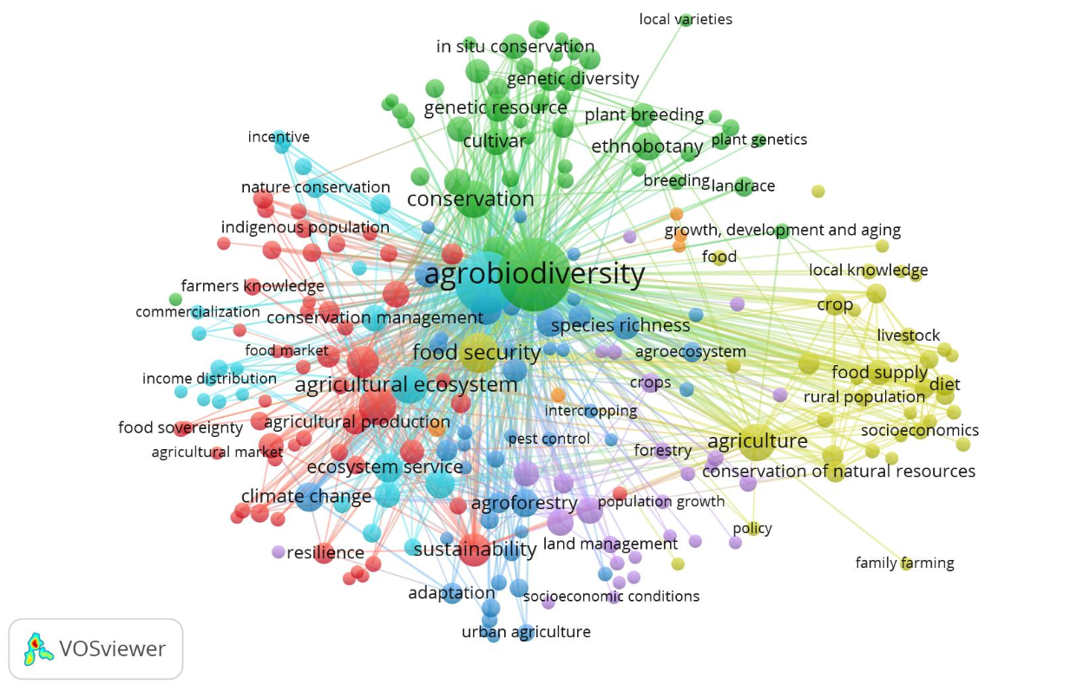

**Research publication trends**

In the last 25 years, 1998 year had the least amount of research published for the HKH region (as retrieved in the scopus), In recent years, the number have increased with highest of 148 publications in 2019. For 2000, data is until the month of May.

The cumulative record show an increasing trend, which means that academic publications for agrobiodiversity and allied themes are gaining attention in the HKH over the years, with publication intensity almost doubling between 2015 and May 2020.

Looking at the contribution of research by HKH countries, there are less publication appearing for countries such as Afghanistan (0.36% representation), Bhutan (1.07%), Bangladesh (2.63%), Myanmar (4.06%). This could either mean that these countries are publishing less in journals which academic literature search engine such as ‘Scopus’ looks at or there are indeed limited efforts for publishing globally. However, there were several publications that reflected cases from two or more HKH countries- these are catergorised under “HKH” categories representing 10.50% of the publications. About 9.79% of the publications reflected knowledge from both HKH and outside-HKH countries such as comparative studies – and these are reflected as “Others” category.

With regard to publications under the four framework pillars, it is realized that research related to FOUNDATION elements of agrobiodiversity have increased substantially between the last decade (2016-May2020) with 172% increase in volume compared to time frame of 2011-2015. There are increase in volume for research for FUNCTION, APPLICATION, and ENGAGEMENT pillars as well with respective increase coming to 128%, 215%, 169%, and 215% between the two 5-years time frame. This implies that research topic reflecting wider socio-cultural, economic, well-being and resilience values of agrobiodiversity are also gaining researchers attention.

**Institutional collaboration**

Institutional collaboration was analysed using authors’ affiliation addresses. Results shows that there are a lot more joint research publication by HKH-International institutions, compared to HKH-HKH institutions collaboration. Sole HKH countries- that is authors from institutions in HKH countries have produced the most academic publications at all time intervals. Publications by HKH-HKH collaborations is lowest at all times. Need to push on more HKH-HKH (ICIMOD+ HKH partners) research collaboration and publications.

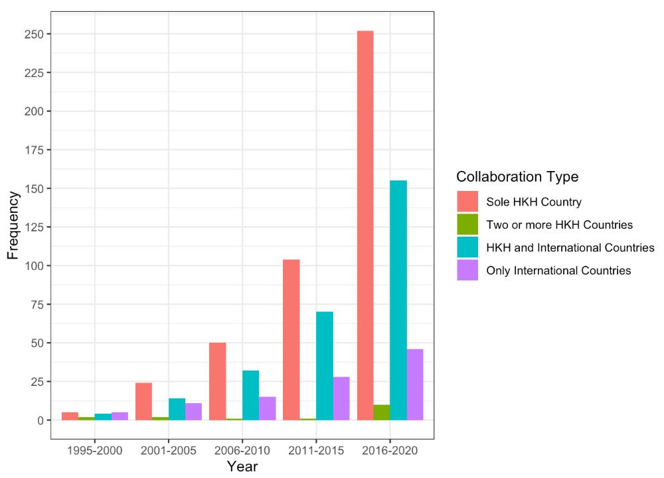

**Relationships and distribution of publication**

An Alluvial plot diagram (from R) below shows the distribution and relationships between agrobiodiversity based publication published in 25 years (1995-May 2020). The three levels in the diagram represent: year, geographic unit, and institutional collaborations. Pattern indicate more volume of literature in the last 5 years from two countries India and China. Publication and institutional collaborations for India and India seems balanced in terms of institutional collaborations at three levels, where with China there seems to be less publication from within-HKH collaboration. Data from Afghanistan, Bangladesh, Bhutan being small compared to other 5 HKH countries, their relationship was difficult to visualize in the Alluvial plot diagram.

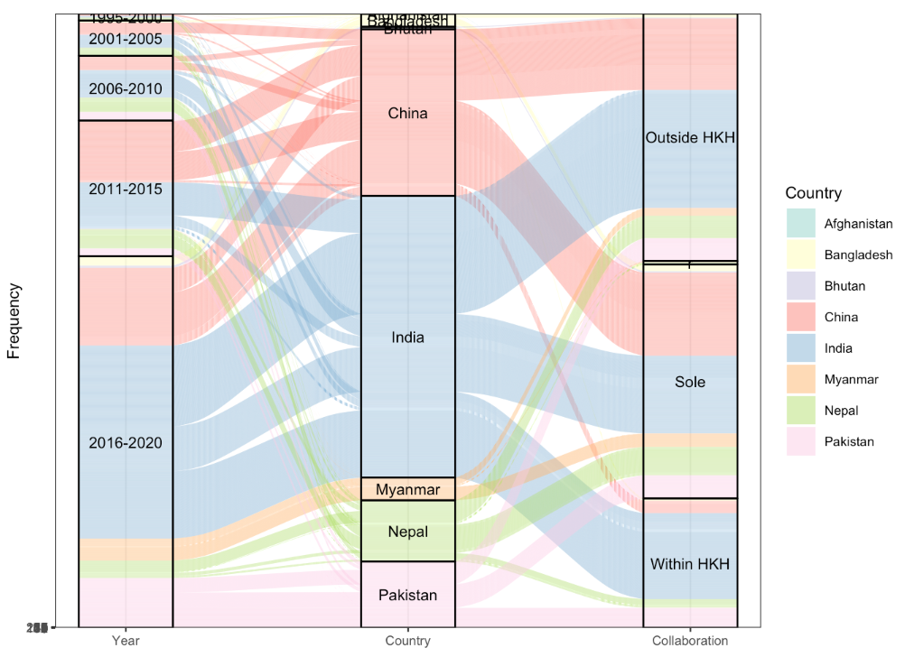

**Knowledge trend (based on keyword analysis)**

A total of 6457 keywords appeared when author and index keywords were combined. It was screened to remove duplicates through use of **plurals** (such as policy/policies, market/markets, fungi/fungus, soil/soils etc), **hyphens** (such as agro-ecosystem/agroecosystem, north-east India/northeast India etc) or **spelling** (such as labour/labor, fertiliser/fertilizer). A total of 6286 keywords were analysed to advance thematic understanding. Since these keywords included both geographic (such as Nepal, china, Himalaya, province, world), thematic (agrobiodiversity and allied themes), and drivers (landuse change, pest and disease, water stress) words, it helped us better review and comprehend the agrobiodiversity context in the HKH region.

Looking at the increasing trend in number of keywords in different time frame in 25 years, it is evident that more publication are coming up over the years and with addition of new research keywords.

**Research topics and themes relevant to agrobiodiversity**

Word cloud diagram is a tool to visualize frequency of keywords. Only keywords with high frequency are reflected in the current diagram. It is clearly evident that agrobiodiversity represents a subset of biodiversity mainly in the agricultural systems, and that food security and climate change topics are highly relevant and associated with agrobiodiversity research publications. Topics related to crop production, conservation, landuse, farming systems, agricultural lands, sustainability, and sustainable development are gaining more prominence in agrobiodiversity research literature.

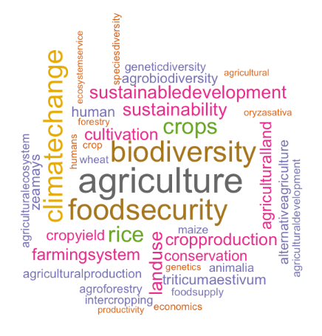

**Frequency of geographic keywords in publication**

It is evident that keywords related to all eight HKH countries are appearing in the publications, with most count for China and India. For each countries, the total number include country name + smaller geographic unit within each countries- such as Tibet, Yunnan, Uttarakhand, Palpa, Kaski, Chittagong Hill tract etc). For the HKH region the number combines keywords - Hindu Kush Himalayan region, Hindu Kush, Himalaya, central Himalayas, western Himalayas, eastern Himalayas.

Keywords related to HKH eight countries are appearing more rigorously in the last five-year time frame (2016-May 2020). Countries such as China and India have appeared significantly since the last one decade. Use of key words relating to the region “Hind Kush +Himalayas” are more visible in the last 5 years.

**Keyword frequencies by four pillars**

Foundation pillar: (This will be described in detail with literature reference)

Majority of publication relate to crops, crops production, cropdiveristy, crop yield. There are publications describing population structure of certain key species, their improvement and domestication. Several publications are dedicated to genetic resources.

Function pillar:

(Detailed description with literature reference later)

Application pillar:

(Detailed description with literature difference later)

Engagement pillar:

(Detailed description with literature reference later)

**Keyword frequencies by drivers**

(Detailed description with literature reference later)

Several drivers have influenced agrobiodiversity in the HKH region. While climate change and landuse appear to be major driving force, several other drivers related to weather, policy, and unsustainable practices are prominent. The challenges (with lower frequency count) - such as crop raiding, yield loss, water shortage, water scarcity, stunting, soil acidification, political conflict, pesticide pollution, pest damage, overexploitation, nutrient deficiency, micronutrient deficiencies, land fragmentation, labour migration, invasive weed, heat stress, ground water contamination, groundwater pollution, environmental pollution, gender disparity, gender inequality, food vulnerability, food contamination, eutrophication, environmental uncertainty, environmental fluctuations, desertification, biodegradation are important, and need to be addressed.

**Agricultural biodiversity in the HKH**

(Detailed description with literature reference later)

Legume is the most important food crops with higher keyword frequency. Larger number of legumes crops have been researched in the HKH.

Cereals are another group of agrobiodiversity that has higher keyword frequency count. It is evident that major cereals like wheat, maize, rice are most researched and have more publications.

Livestock, underutilized crops, insects, vegetables have also received significant research contribution.

Microorganisms (bacteria, virus), Fungi have been studies in relation to plant diseases.

Fish and aquatic biodiversity is among the least reported in publication

Plant species group comprises publication related to fodder species, wild edibles, crop wild relatives, pollinator flora, and invasive species. Likewise animals include poultry species, dispersal animals, animals associated with crop raiding.

**Level 2: Intervention compliance analysis**

**Identification of interventions**

Interventions that could influence the four key pillars of the framework - foundation, function, application, and engagement – were identified from the keyword indices. The table below outlines 13 interventions and relative keywords suggesting the themes or issues incorporated within the given intervention.

|  |  |
| --- | --- |
| **Intervention type** | **Keywords included (indicates themes or issues to be addressed)** |
| Integrated food system management | Food production, food processing, food and livelihood security, food and nutritional security, food biotechnology, food grain production, food handling, food industry, food provisioning, food retailing, food supply chain, food value chain, future smart crop, future smart foods, nutrition management, nutrition security, nutrition-sensitive agriculture, postharvest processing, slow food development, slow food tourism, value-added processing, short food supply chain, agri-food supply chains, agri-food governance, agri-food knowledge, agri-food systems, agri-food system transformation, community food security, organic food production, |
| Farm-water management | Water conservation, ground water irrigation, rain water harvesting, water management, controlled irrigations, "irrigation intervention, irrigation management, irrigation scheduling, irrigation water management, spate irrigation, water consumption, water harvesting, water planning, water quality protection, water recycling, water treatment, wetland recreational agriculture |
| Livestock management and aquaculture | Livestock farming, animal husbandry, aquaculture, pastoralism, agro-pastoralism, cattle farming, compensation system, dairy farming, dairy production, diversified fish-rice agroecosystem, grazing management, livestock intensification, livestock production, milk production, nomadic pastoralism, pastoral development, stall feeding |
| Intensive mechanised agriculture | Agricultural intensification, intensive agriculture, green revolution, monoculture, mechanization, cash cropping, agricultural commercialization, commercial cultivation, commercial plantation, crop intensification, industrial ecologicalization, industrial management, industrial production, intensification of cropping systems, intensified agricultural system, large scale production, rubber specialization, system of crop intensification, agricultural mechanization |
| Integrated land management | Rural development, land management, landuse planning, landscape planning, land consolidation, habitat restoration, spatial planning, landuse management, land transfer, land tenure security, Vegetation remote sensing, traditional land management, sustainable landuse development, sustainable rural development, sustainable landuse, space arrangement, sloping land conversion program, sloping agricultural land technology, rural land transferring, rural planning, rural revitalisation, rural transition, upstream-downstream linkages, urban planning, urban-rural integrated development, land titling, landscape ecological planning, landscape assessments, land renting-in, land evaluation, habitat manipulation, eco-distribution mapping, dryland farming, cultivated landuse decision-making", cropland expansion, cropland |
| Home garden management | Home garden, home garden systems and practices, home stead forests, house gardens, kitchen garden |
| Innovative livelihoods development | Agribusiness, economic development, agro industry, tourism development, agritourism, commercialisation, certification, ecotourism, supply chain management, poverty alleviation, rural economy, small and medium enterprises, sustainable livelihood, business development, eco-agricultural tourism, heritage tourism, agricultural heritage systems tourism, industrial development, value chain, social development, socioeconomic development, vulnerability assessment, agricultural co-operatives, agricultural marketing, agricultural trade, agriculture entrepreneurship, agripreneurship, bio economic modelling, brand management, community entrepneurship, cultural tourism, ecological industrialization, e-commerce agribusiness, enterprise resource planning, environmental compensation, gastronomy tourism, global poultry trade, incentive mechanisms, international trade, market development, rural tourism, small family business, social marketing, social sustainable entrepreneurship, whole industry chain, contract farming, economic reform, income generation, livelihood enhancement, livelihood improvement, livelihood improvement and homestead vegetable cultivation, livelihoods diversification, off-farm employment, rural employment |
| Integrated mixed (organic) farming | Soil conservation, sustainable intensification, organic farming, conservation agriculture, biological control, ecosystem service, conservation planning, mixed farming, double cropping, hedge row intercropping, contour hedge row intercropping, seasonal intercropping, crop rotation, integrated pest management, crop management, sustainable production, conservation tillage, reduced tillage, minimum tillage, zero tillage, strip tillage, tillage management, integrated farming, precision agriculture, composting, mulching, soil amendment, soil and water conservation, soil carbon sequestration, soil survey, biomass production, niche partitioning, recycling, straw management, weed control, emergy evaluation, alluvial farming, beekeeping, ecological agricultures, ecosystem management, energy conversion, restoration ecology, "green production, residue management, aerobic composting, green manuring, in-situ live mulching, nutrient acquisition, nutrient cycling, nutrient dynamics, nutrient enrichment, precision nutrient management, soil analysis, soil conservation practices, soil improvement, soil management, soil remediation, folk soil taxonomy, agricultural demonstration, GIAHS, NIAHS, mixed mountain agriculture, disease management, ecological intensification, fruit production, hand weeding, honey production, improved agronomic practices, maize/legumes intercropping, non-grain production, pest and disease management, pollination management, sericulture, vegetable farming, waste management, waste treatment, weed management, crops/cropping system diversification, system development, traditional agrodiversity, traditional farming, traditional management practices, agriculture green development, bio-composting, biological pest control, crop-livestock-agroforestry, eco-agriculture, organic cultivation, organic matter production, runoff recycling |
| Sustainable agriculture development | Sustainable crop production, agricultural development, agricultural production, sustainable agriculture, agricultural management, shifting agriculture, agricultural ecosystem, traditional agriculture, alternative agriculture, climate smart agriculture, catering service, pest control, subsistence agriculture, agriculture development, horticulture, agricultural diversification, agricultural research, hill farming, species inventory, terrace agriculture, upland cropping, water saving agriculture, agriculture sustainability, agriculture monitoring, agriculture planning, arable farming, community supported agriculture, contemporary agriculture, conventional agriculture, diversified shrimp-rice agroecosystems, integrated agriculture-aquaculture, reconciling agriculture and ecosystems, precision farming, shifting/jhum/slash-and-burnfarming, small-scale farming, subsistence cereal farming, subsistence farming, whole-farm model, valuation, sustainability assessment, sustainable agricultural intensification, sustainable utilization, sustainable phosphorus management, grain production transition |
| Innovative agroforestry | Agroforestry, carbon sequestration, forest management, plantation forestry, farm-forest relation, forest plantation, ntfp domestication, reforestation, agroforestry adoption, community-based agroforestry system, community forestry, emission mitigation, emissions trading, national horticulture mission, payments for ecosystem services, small holder rubber plantation, traditional agroforestry |
| Crop improvement | Fertilizer application, crop improvement, domestication, plant breeding, genetic analysis, diversification, seed treatment, conservation genetics, crop diversification, genetic selection, hybridization, participatory plant breeding, plant growth promotion, gene editing, genetic engineering, genetic improvements, molecular analysis, seedling establishment, seed management, arsenic mitigation interventions, biodiversity deployment, community based seed production, community seed systems, crop improvement program, crops disease diagnosis, dna modification, gene identification, genetic speciation, gene transfer, genome editing, genome sequencing, genome-wide association study, genomics-assisted breeding, consumer-oriented breeding, participatory breeding, host-symbiont interaction, landrace enhancement, marker-assisted selection, micro propagation, molecular characterization, morphometric analysis, next-generation sequencing, on-farm interventions, on-farm management, on-farm research, phylogenetic analysis, quality improvement, radiative diversification, rapid development, seedbed preparation, seed replacement rates, sequence analysis, species differentiation, seed technology |
| Integrated resource conservation | Conservation, environmental protection, conservation management, conservation of natural resources, on-farm conservation, environmental management, in-situ conservation, nature conservation, agrobiodiversity conservation, habitat conservation, species conservation, biodiversity conservation, ex-situ conservation, on-farm reservoir, plant protection, resource conservation, environmental restoration and remediation, agroecosystem planning, biosphere reserve, community resource management, conservations, consumer-oriented germplasm conservation, eco-geochemical assessment, ecological management, ecological protection, ecological value assessment, ecosystem protection, ecosystem restoration, energy conservation, environmental conservation, genetic conservation, genetic resources conservation, germplasm conservation, heritage conservation, on-farm conservation, natural forest conservation program, plant conservation, protection of plant variety |
| Adaptive system planning and development | Adaptive management, sustainable development, urbanization, climate change adaptation, regional planning, environmental planning, environmental monitoring, resource management, machine learning, technological development, technology adoption, technology transfer, capacity building, environmental assessment, infrastructure development, international cooperation, performance assessment, planning, policy development, agricultural modeling, local knowledge, participatory research, participatory rural appraisal, women's empowerment, adaptive strategies, adaptive transition management, evolutionary adaptation, gender and autonomous adaptation, agro-biodiversity assessment, agrobiodiversity management, belt and road initiative, best management practice, community biodiversity management, , educational development, education and knowledge, poverty alleviation, employment, energy production, environmental decision making, ethnographic research, ever green revolution, government intervention, grain for green policy,  "grain-to-green program, regional agricultural demonstration, regional development, research and development, research and development management, risk management, sustainable regional development, urban agriculture, agricultural engineering, intelligent information processing, internet of things in agriculture, social sciences computing, technological revolution, technology protection, capital-labor dual intensifying, diversified utilization, extension education, farmer advisory services, farmer field schools, farmers' organization, farm technology intensification, feminization of agriculture, gender mainstreaming, Himalayan honey hunting, institutional arrangement, institutional innovation, interdisciplinary collaborative effort, inter disciplinary innovations, participatory management, stakeholder management, strategic planning, ecological civilization |

**Identification of relevant SDGs target**

SDGs target mentioned in the HIMAP documents were used. In this systematic review the following relevant SDGs target are selected considering their relevance to wider values of agrobiodiversity and the scale for intervention.

|  |  |  |
| --- | --- | --- |
| **SDGs** | **Target** | **Scale\*** |
| 1.1 | Reduce income poverty | Landscape |
| 1.2 | Reduce non-income poverty | Landscape |
| 2.2 | Ending malnutrition, food and nutrition insecurity | Landscape |
| 2.3 | Higher income for small-scale farmers | Local |
| 2.4 | Sustainable food production systems and resilient agricultural practices | Local |
| 2a | Rural agriculture infrastructure | Local |
| 5.5 | effective participation and equal opportunities for leaderships | Local |
| 5c | Policies and legislation for gender and social inclusion | HKH |
| 6.4 | Water supply for key development sectors | HKH |
| 6.5 | Implement monitor transboundary cooperation | HKH |
| 6b | 6 b Participation of communities in water management | Local |
| 7.1 | Increase access of energy for women decreasing their workload | Local |
| 8.1 | Sustain per capita economic growth | HKH |
| 8.2 | Higher levels of economic productivity through diversification, technological upgrading and innovation | Local |
| 8.3 | Policies that support productive activities, decent job creation, entrepreneurship, creativity | Landscape |
| 8.5 | Full productive employment and decent work | Local |
| 8.8 | Safe and secure working environment | Local |
| 8.9 | Promote sustainable tourism that creates jobs and promotes local culture and products | Landscape |
| 9.1 | Sustainable and resilient infrastructure | Landscape |
| 9.3 | Increase the access of small-scale industrial and other enterprises- value chain | Landscape |
| 9.4 | resource-use efficiency and greater adoption of clean and environmentally sound technologies | Local |
| 10.1 | Income growth of the bottom 40 per cent of the population | HKH |
| 10.2 | Social, economic and political inclusion of all | HKH |
| 11.4 | Safeguard the world’s cultural and natural heritage | HKH |
| 11.5 | Reduce economic loss due to extreme climate | Landscape |
| 12.2 | Sustainable management and efficient use of natural resources | Local |
| 12.3 | Food waste at the retail and consumer levels and reduce food losses along production and supply chains, including post-harvest losses | Landscape |
| 12.8 | Awareness for sustainable development and lifestyles in harmony with nature | Landscape |
| 13.1 | Strengthen resilience to climate related hazards | Landscape |
| 13.2 | Integrate climate change measures into policies | HKH |
| 15.1 | Conservation, restoration and sustainable use of terrestrial and inland freshwater ecosystems | Landscape |
| 15.2 | Sustainable management of all types of forests | Landscape |
| 15.3 | Combat desertification, restore degraded land and soil, | HKH |
| 15.4 | Conservation of mountain ecosystems | HKH |
| 15.5 | Reduce ecosystem degradation | Landscape |
| 15.6 | Fair and equitable sharing of the benefits arising from the utilization of genetic resources | HKH |
| 15.7 | Minimize human wildlife conflict | Local |
| 15.8 | Impact of invasive alien species | Landscape |
| 15.9 | Integrate ecosystem and biodiversity values | Landscape |
| 15a | Increase investment in EBA | HKH |
| 16.6 | Develop effective, accountable and transparent institutions at all levels | Landscape |
| 16.7 | Number of women in institutions | Landscape |
| 17.1 | Domestic resource mobilization | HKH |
| 17.2 | Multi-stakeholder partnerships | Landscape |
| 17.2 | Public-private partnerships | Landscape |
| 17.2 | Database for species | Landscape |
| 17.6 | Access to science, technology and innovation | Landscape |
| 17.7 | Environmentally sound technology promotion | Landscape |
| 17.8 | Enabling information and communication technologies | Landscape |
| 17.9 | Capacity building international support | Landscape |
| *  Local= Targets that are directly relevant to communities on the ground, and requires direct engagement of local level stakeholders  Landscape= Targets that require engagement of interdisciplinary actors and greater intersectoral (technical) coordination, and beyond local scale actors  HKH= Targets that require cooperation between countries, and scope goes beyond technical cooperation- requires strategic interventions | | |

**Compliance analysis**

The compliance analysis was done for 13 identified interventions to assess their potential in achieving the transformative change as envisioned by the interdisciplinary targets of the SDGs.

Compliance analysis include influence exercise using the score between +2 to -2 as per the following guidelines.

When interventions and targets are “INDIVISIBLE” +2 score was given

When interventions and targets are “REINFOCING” +1 score was given

When interventions and targets are “CONSISTENT” 0 score was given

When interventions and targets are “CONSTRAINING” -1 score was given

When interventions and targets are “CANCELLING” -2 score was given

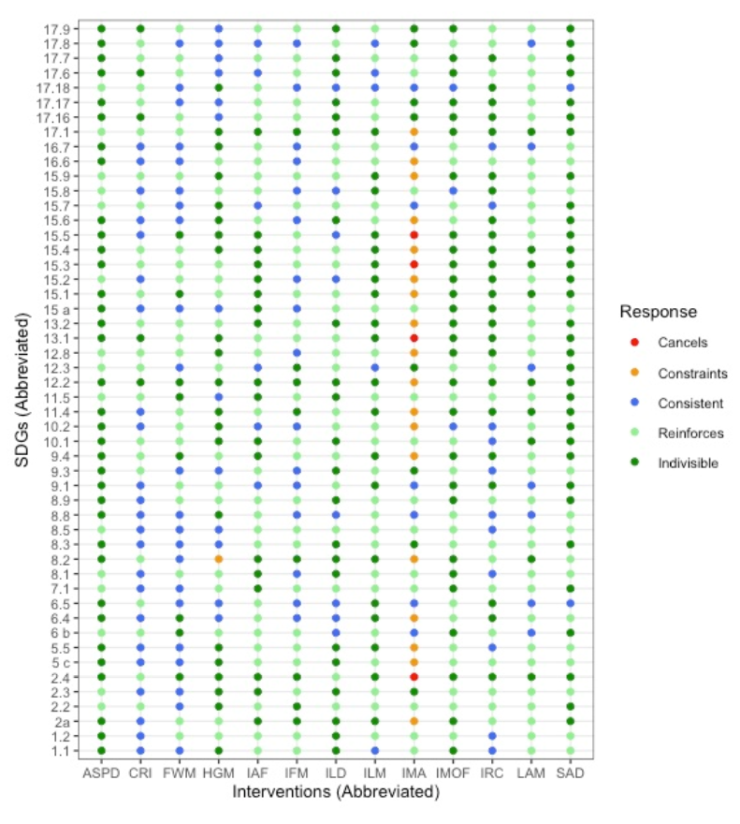

**Prospect of agrobiodiversity based interventions to bring transformative change**

(Detailed description later with references)

Looking at the strength of each interventions, interventions with broader implications such as adaptive system planning and development, and sustainable agriculture development had greater strength compared to focussed interventions such as crop improvement, home garden management, and farm water management. Intensive mechanised agriculture is not a viable intervention option when it comes to bringing transformative change in the HKH.

The bioplot diagram obtained through principal component analysis of relationships between the 13 interventions against the 50 SDG targets, reveal positive relationships between interventions 8 interventions (LAM, IAF, ILM, HGM, IRC, FWM, IFM, CRI) that are positive to component 1- more likely to diversify agrobiodiversity resources and conserve them. Interventions such as ASPD,SAD, IMOF that are positive to component 2 are more oriented to sustainability therefore may not be totally resource conservation oriented, but are nevertheless contribute to transformative change including agrobiodiversity conservation. The two interventions IMA, ILO appear negative to both component therefor may be less desirable to promote all SDGs target.

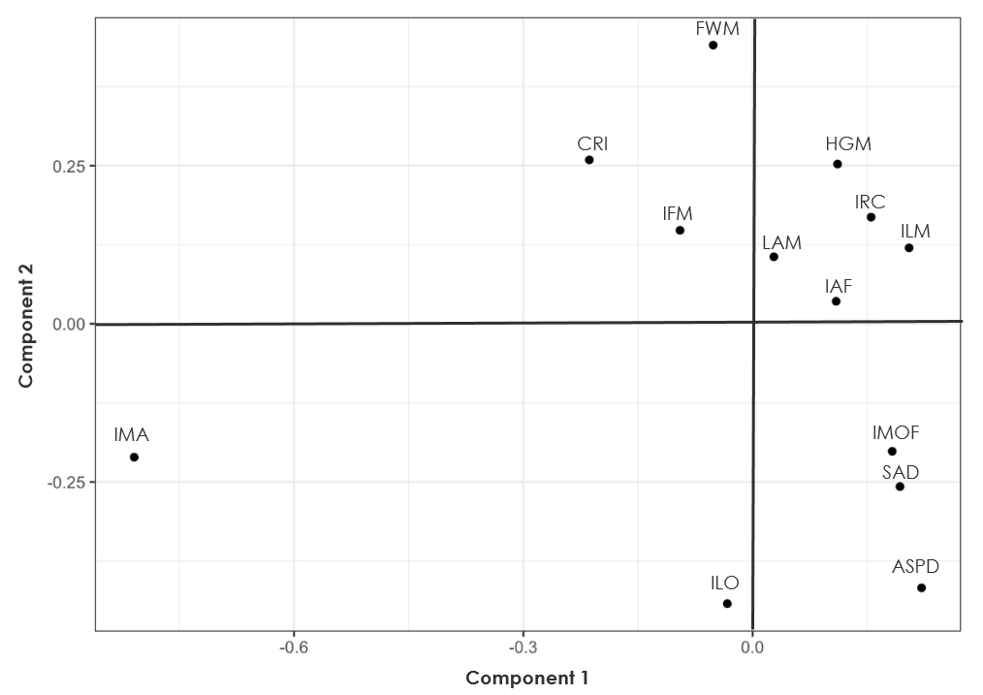

**Level 3. Action Framework Development**

(Details with reference will be done later)

Based on the systematic review, and results in the HKH, we propose a multiscale and transdisciplinary framework based on the four pillars -Foundation, Functions, Application, and Engagement – that indicates interdependent values of agrobiodiversity. The framework thus helps us to see agrobiodiversity as an integrated set of thematic discourses that needs to be managed holistically considering its biological, bio-cultural, economic and well-being and resilience-adaptive values. The four pillars are interdependent therefore is presented here as one unit. The unit as a whole lets us address objectives and challenges at different scale of interventions- local scale (farming systems and community level), Landscape scale (beyond the farm and at national level) and HKH scale (transboundary and regional level). It gives us the prospect to address key challenges and associated objectives for each pillar, and cumulatively achieve the broader goal of sustainable development.

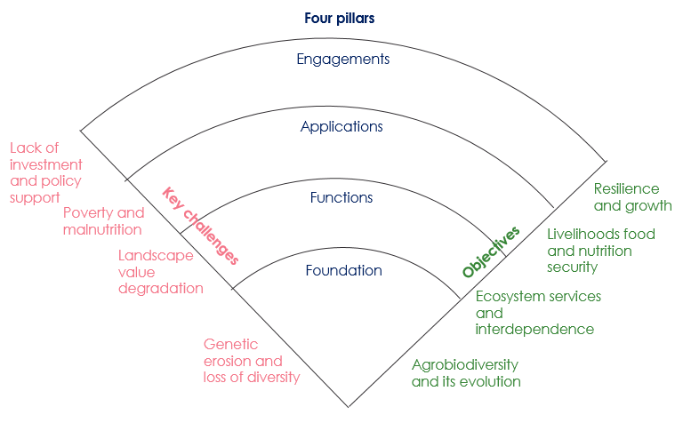

In order for this framework unit to bring transformative change, has to be seen against the spectrum of how effective it can be in terms of addressing multidimensional objectives and in integrating wider values (figure below). As a unit, as we move from FOUNDATION pillar to ENGAGEMENT pillar, higher is the integration of wider topics and values and addressing of broader objectives. The multiscale transdisciplinary action framework presents a two-step process of i) assessing the scenario of the ‘unit’ looking into different thematic elements within each pillar, and ii) identifying and applying various research, management and policy actions to bring progressive change for agrobiodiversity in the landscape- that is progress towards transformative change.

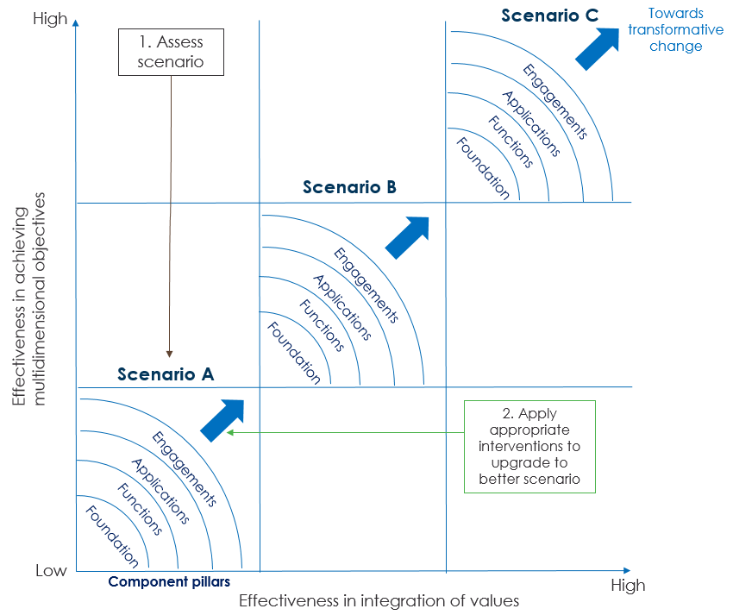

**i)Assessing scenarios in the Landscape**

The following table can be referred to assess respective scenario in a particular landscape. The assessment tool brings indicators and measurement values for each of the four pillars of the framework unit.

*(*During the HKPL workshop the participants can try this exercises to see scenario in the HKPL landscape)*

|  |  |  |  |
| --- | --- | --- | --- |
|  | **Scenario A** | **Scenario B** | **Scenario C** |
| **FOUNDATION PILLAR (enhances biological values)** | | | |
| **Agrobiodiversity inventory** | Absent | Sporadic | Complete |
| **Production landscape** | One type | Diversified | Diversified and integrated |
| **Farm productivity** | Low: Subsistence oriented | Moderate: differentiated production for household consumption and market | High: adequate volume and diversified products for both consumption and market |
| **Use of wild edibles** | Few harvested for household consumption during low food secure time | Regularly utilized as part of the traditional cuisines | Diverse species sustainably utililized and promoted as part of the tradition and healthy rural food and diet |
| **Homegarden culture** | Small, comprises species of regular household use | Moderate with diverse types of food crops including some wild edibles | Large, stratified and diverse; new crops tried and experimented |
| **Germplasm source** | Delicate- mostly dependent on what is available with household and neighbours | Maintained- using improved varieties, but traditional varieties available from network of farmers, ex-situ germplasm supported | Improved- local and traditional varieites presrved and used; in-situ improvement of germplasm, well established Community seed bank and ex-situ germ plasm support |
| **FUNCTION PILLAR (enhances biocultural values)** | | | |
| **Ecosystem services mapping and awareness** | Only acadmia are aware through sporadic research | Knowledge limited to selective stakeholders | Coproduced and all stakeholders aware |
| **Valuation of services** | Absent | Pilot | Complete accounting |
| **Use and application of traditional knowledge** | Minimal with traditional knowledge almost non-existent | Uneven with some older generation farmers still engaged | Knowledge still guided by traditional institutions |
| **Integration of modern knowledge and technology** | Applied without adequate knowledge and capacity | Applied when support is available | Research led application and adequate extension support |
| **Soil fertility management** | Deteriorating through high use of chemical fertilizer | Maintained through use of both organic and chemical fertilizer | Excellent soil health and nutrient management through organic and biodynamic composting technologies |
| **Water management for farm** | Inadequate: < 25% have irrigation facility and using LCWM technologies, mostly dependent on rainfall | Manageable: 25-60% using irrigation facilty and using LCWM technologies; risk of deterioration of watershed | Efficient: >60 % have access to irrigation facilities and using LCWM technologies, government water supply available, watershed and aquifer well maintained |
| **Aesthetic services** | Low: uniform production landuse, less pollinators and pesticide pollution prevalent | Moderate: diversified production landuse, adequate pollinators, well maintained farmlands and limited for household consumption and market | High: Well-maintained diversified and integrated landuse with excellent farm-forest connect. Abundant pollinators and agritourism established |
| **APPLICATION PILLAR (enhances well-being values)** | | | |
| **Migration context and engagement in farming** | High (<25% of population engaged) | Moderate (25-60% of population engaged) | low (>60% of population engaged) |
| **Willingness of farmers to invest and innovate** | low (given lower inconomic status) | Moderate (small scale investments) | High (collaborative investments and partnerships) |
| **Intra/intergenerational support** | Only a few members in a family enaged | Women/ men both engaged but less younger generation | Well differentiated roles and younger generation well engaged |
| **Food security for farming communities** | Severe (>3 months of food shortage) | Frequent (1-3 months) | Absent (0 months) |
| **Food cooperatives** | Few and limited farmers engagement | Several and majority of farmers engaged | Interconnected set of coopratives with engagement of most farmers including womenall cooperative) |
| **Dietary and food environment** | Moderate: <20 % eating healthy, disappearing local cuisines, food safety and nutrition awareness low | Promising 25-60% eating healthy food, traditional cuisines diluted. Food safety and nutrition awareness moderate | Diverse - >60% eating healthy, local cuisines well promoted, divesified food types used. Food safety and nutrition awareness high |
| **ENGAGEMENT PILLAR (enhances resilience value)** | | | |
| **Land tenure and farming** | Low (<25% of farmers own land and used for agriculture) | Medium (25-60% of farmers own land and use for agriculture | High (>60 of farmers own land and use for farming) |
| **Conservation support from government** | Minimal and limited outreach | Available but biased outreach | Well supported and timely outreach |
| **Institutional support** | Low (local institutions are supported temporarily) | Medium (network of local institutions supported by several external institutions | High (Network of local institutions well supported by national and international collaborative partnerships |
| **Government subsidies** | Random and unequitable | Equitable but not aligned to community specific needs | Well aligned to community specific needs |
| **Financial support to farmers** | Hard to get credit for investment or limited to a few farmers | Adequate access to microcredit facilities, loan process still complicated | Adequate access to microcredit, insurance, other risk mitigation measures in place, facilitated process for needy farmers |
| **Market connect** | Farm produce reach local market | Farmers produce reach both local and national market | Farmers product branded and connected to local, national, international market |
| **Farm mechanization** | Manual: difficult and inappropriate for adoption | Progressive: Animal traction/ small scale technology and farm machines in use where farmers can afford | Innovative: mountain specific farm and farmers friendly mechanics and other implements available and used |
| **External inputs by farmers and use of inputs** | High: >60% farmers reliant on external input, inequitable outreach to external input | Moderate: 25-60 farmers using external input, access and input deliveries fairly good | Self-sustained <25% dependent on external inputs, on-farm technology established for inputs -organic manure and bio fertilizers. Technical backstopping inputs very good |
| **Market access (road and communication)** | Minimal: only connected to local market, road and communication infrastructure limited | Moderate: connected to wider national market, village road network well developed and communication well established. | Efficient: market well established both nationally and internationally. Effective value chain partnerships |

**Recommended interventions**

Table below provides prospective list of research, management and policy actions that could help the landscape progress the agenda for agrobiodiversity management in the landscape, in a way it brings wider transformative change and helps HKH countries collectively achieve the SDGs

Research actions

|  |  |
| --- | --- |
| Foundation | * Crop/livestock diversification and improvement * Ethnographic research on niche mountain crops/livestock * Species inventory, database and information management systems * Phylogenetic analysis of crop wild relatives * Genomic studies of major species including NUS * Soil nutrient dynamics * Soil microbiomes functions |
| Function | * Valuation of ecosystem services from mountain agriculture * Ecosystem services flow between farm and natural landscape * Mapping of ethnic community based traditional knowledge and practices- farm management, local cuisines * Emergy analysis (input-output) * GIAHS and NIAHS assessment |
| Application | * Biofortification * Nutrient analysis of NUS and traditional cuisine * Ethnobotanical research on benefits and use of biodiversity in and around farms * Value chain analysis of NUS crops |
| Engagement | * Sustainability assessment of farming systems * Environmental Impact assessment * cost-benefit and comparative account of different production systems |

Management actions:

|  |  |
| --- | --- |
| **Foundation** | * Maintain agroforestry landuse and promote use of valuable species * Establish decentralised seed banks and nurseries for local agrobiodiversity taxa * Escalate domestication of multipurpose trees that can provide food, fodder, fruit and medicines * Domesticate and improve management of high-value perennial fruit trees for income generation * Strengthen capacity of local farmers on efficient farm management technologies * Promote use of locally adapted and native varieties on marginal farmlands and provide special provision for farmers for maintenance of local races, cultivars and breeds * Maximize use of available production landscape through diversity farming * Promote homegardens |
| **Functions** | * Organize awareness raising event for mountain agrobiodiversity and its wider use and services and promote agritourism * Enhance farm-forest connectivity through agroforestry practices * Attend to human-wildlife conflict * Promote organic cultivation to avoid pesticide use and pollution * Innovate soil management technologies as per the need of different production systems - pasture, cultivated terrace, agroforestry, fallows forests, shifting cultivation slopes, and intercrops areas * Promote use of both modern farm technologies and traditional practices to enhance value of agricultural landscapes * Innovate intercropping techniques and vertical agri-horti-silvi farming * Promote diversity farming to deal with pest, weeds, diseases, and crop raiding and livestock depredation * Invest in modern irrigation and water provisioning systems together with integrated watershed management to reduce water-runoff from farm and forests * Restore degraded habitat and enhance aesthetic significance of landscape. |
| **Application** | * Foster access to credit for farm-business, and diversification of types of farm products * Put market information service in place for farmers to support farm production * Enhance value chain development capacities * Establish financial incentive mechanism to implement organic farm management and scientific development and monitoring * Strengthen post-harvest facilities and capacities of farms to store food and minimize crop damage, spoliage or waste |
| **Engagement** | * Strengthen local community institutions for eco-friendly agriculture and a common set of shared beneﬁts * Ensure technology transfer and promote peer-peer learning at all scales * Reinforce traditional knowledge and participatory resource management * Create network farmers portal to highlight knowledge and experience of farmers looking after different production landscape * Strengthen government extension services mechanisms to enrich access to inputs to farm such as farm implements, fertilisers, seeds, saplings, water, technical backstopping * Design appropriate mountain specific farm machinery and soil water management technologies to increase farm-efficiency and decrease farmers work load, and make farm operation energy and climate smart |

Policy actions:

|  |  |
| --- | --- |
| **Foundation** | * Support establishment of decentralized seed bank and nurseries for local forest and crop species * Support regional exchange of livestock germplasm exchange to avoid inbreeding * Develop local strandards for access and benefit sharing * Generate grants and payments to evolve future food crops and new varieties and breeds * Facilitate in-situ germ plasm conservation |
| **Function** | * Put in place necessary inputs tools and policies for organic agriculture * Reinforce traditional knowledge with participatory resource management and tenure on land and resource use * Strengthen community institutions and capacities for integrated landscape management and governance * Ensure protection of agrobiodiversity germplasm and wild edibles in the protected areas * Recognize, designate and engage communities for GIAHS and NIAHS. |
| **Application** | * Establish eco-certification process to obtain premium price for mountain agriculture produce * Create enabling global trade environment for local communities * Mainstream school farm, school food programme and dietary education * Reorient national investments for integrated and diversified farm management |
| **Engagement** | * Strengthen support for ex-situ conservation and capacities for biotechnological germplasm development * Organize agri-tourism oriented multi-stakeholder dialogue to promote non-opportunistic and investment and cooperation * Strengthen capacities of local government to better extension outreach * Formulate standards for access and benefit sharing and payment of ecosystem services for farmers promoting integrated organic farming * Improve basic development facilities- water, energy, education, health and sanitation, communication, transportation in the rural villages |